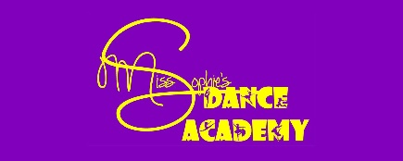
ZOOM LOCKDOWN 2
CHALLENGE CARD
GRADE 1 BALLET
Instep Stretches – working through the feet
Sways and Gallop with arms
Plie in 3rd
Rise in 3rd
Grand Plie in 2nd
Retire (to draw) – petit (small) & grand (big)
Glisse to 2nd
Degage devant & derriere with & without plie
Grand Battement devant – (big beat in front)
Grand Battement derriere – (big beat behind)
All arm positions – 1st, 2nd, 3rd, 4th, 5th
Echappe saute to 2nd – to escape, jump feet apart
Sautes in 1st & 3rd – to jump
Changements – Jumps with change of feet
Glissade – devant (infront) & derriere (behind) to glide
2 Skips backwards with two spring points
Pose Temp Leve in Attitude devant – step hop with bent leg
Step close on a rise in 3^{rd,} step hop – straight leg
Walks with stretched feet

Teachers will advise when these can be ticked off
A completed Challenge Card will be rewarded with a medal

